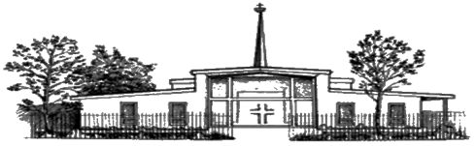
The Catholic Church in Park Gate
St Margaret Mary
www.stmargaretmary.co.uk

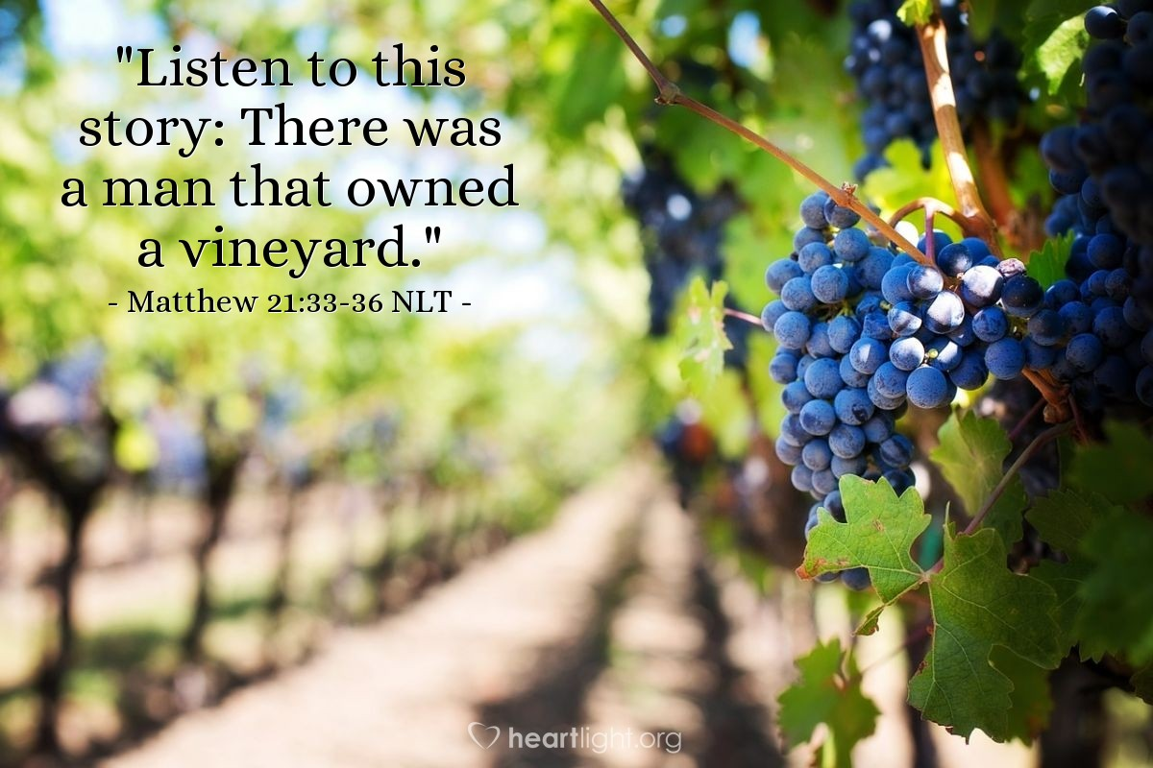
Sunday 4th Oct TWENTY-SEVENTH SUNDAY IN ORDINARY TIME (Psalter Week 3)
8.30am People of the Parish
10.30am Joan Kennedy RIP
6.30pm Clare & George Grima RIP

Monday 5th 9.30am No Mass
7pm No Adoration
Tuesday 6th 9.30am No Mass
Thursday 8th 7pm No Mass
Friday 9th 9.30am No Mass

Sunday 11th TWENTY-EIGHTH SUNDAY IN ORDINARY TIME (Psalter Week 4)
8.30am Rose & Francis Hanley RIP
10.30am People of the Parish
6.30pm Graham Nixon RIP

Refreshments are served in the Parish Hall after the 10.30am Mass on Sunday.
2026
Catholic Diocese of Portsmouth (reg. Charity No: 1199568)
“Bringing people closer to Jesus Christ through His Church”
Short Reflection on this week’s Gospel – Matt 21 v 33-43
There was a certain landowner who planted a vineyard and set a hedge around it: Jesus told of a landowner who prepared his vineyard carefully and hired men to manage it (the vinedressers). The men who were supposed to manage his vineyard mistreated and killed the messengers sent by the landowner. Finally, he sent his son, and they killed him also – foolishly believing they would take control of the vineyard. Yet the response of the landowner was not to yield to the vinedressers but to judge and destroy them.
They will respect my son…This is the heir. Come, let us kill him and seize his inheritance: Jesus portrayed the madness of the chief priests and elders who plotted to kill the Father’s Son sent to the rebellious leaders of Israel.
Have you never read the Scriptures: This manner of speaking to the chief priests and elders of Israel must have angered them. Jesus speaks to the leading theologians of Israel and asks them if they have ever read their Scriptures.
The stone which the builders rejected has become the chief cornerstone: Jesus quoted this from Psalm 118 to remind them that their rejection of Him said more about their guilt and coming judgment than it said about Jesus Himself. Though they reject Him, He is still the chief cornerstone, fulfilling the great Messianic Psalm 118.
Clearly, Jesus claimed to be the rejected stone of Psalm 118:22-24 that God appointed to become the chief cornerstone. He is also the stone of Isaiah 8:13-15 that people stumble over, the foundation stone and precious cornerstone of Isaiah 28:16, and the stone of Daniel 2:34, 44-45 that destroys the world in rebellion to God.
The kingdom of God will be taken from you and given to a nation bearing the fruits of it: Jesus warned the religious leaders that if they continued their rejection of God and His Messiah, they could expect that God would pass the leadership of His work on earth to others.
Jesus’s words remind us of the importance of staying faithful to Him, and His teaching. As His followers, we are guardians of the Christian faith. Let’s pray that the Lord, despite the challenging and sometimes hostile world we live will continue to give us the grace to live a Holy life and to take up the challenge of going out to the nations and preaching the good news. Matt 28 v 19.
Fr Ansel’s Day is away with Parish Pilgrimage to Fatima from 1st-9th October. For any urgent sick calls during this time, please contact Cn John Cooke at Sacred Heart, Fareham on 01329 318869.
The Prayer Garden and Church will be open during office hours while Fr Ansel is away.

Mass Intentions. To book a Mass intention/s, please contact the Parish office by phone, email or in person. If you leave an envelope outside office hours, please put all your details on envelope. The most important thing is that the sacrifice of Mass if offered, but we cannot guarantee the date. If you make a donation via BACS, please include reference of ‘massint.’ Thank you.
Standing Orders and Gift Aid.
Thank you for all you do to support your parish in many different ways.
If you have not already done so, please consider donating via a standing order and sign up for gift aid, in order to provide a more stable, and 25% extra parish income. Forms available on the website, at the back of the Church and from the Parish office.
Also, scan this QR code to donate online.

DONA machine – Contactless giving available in foyer of Church.
Do you need our bank details?
CDP PARK GATE ST MARG MARY
Sort Code: 30-93-04 Account Number: 00883663
Gosport Section of the Catholic Women’s League are meeting at 1.30 pm in the Hall of Our Lady of the Immaculate Conception, Stubbington, on Wednesday 14th October. Our group consists of members from all the parishes in this area and we would welcome visitors, so come and see what we do. For further information, please contact
Marguerite Boulter 07751 435487 margieboulter@aol.com
Maria Owen 07790 378 097 mariaeowen@gmail.com
Padre Pio Prayer Group – The next meeting will be Sunday 25th October at 7.45pm
You are all most welcome. For more information, please contact David Walford: walford101@hotmail.com



Vinnie’s Café – Saturday 31st October 2-4pm in the ST. Margaret Mary Parish Hall.
Come for a friendly chat and a cup of tea. All welcome. Free, but donations welcome.

Friday Coffee morning – Join us in the Paray room after morning Mass. No coffee morning 2nd or 9th Oct.

Dates for your diary:
October 18th – PATRONAL FEAST & 60TH ANNIVERSARY CELEBRATION
After 10.30am Mass in the Parish Hall. Bring & Share (finger foods only, no nuts) If you have any photo’s, etc of our rich history you would like to share for display please contact maggie@raymontc.plus.com
PUTTING ON THE GLITZ – LADIES NIGHT – 13TH NOVEMBER FROM 7.30PM IN THE CHURCH HALL.
A fun evening of pre-Christmas sparkle and an opportunity to purchase new/nearly new partywear and accessories for the festive season at below January sale prices. Light supper provided, BYOB. Tickets on sales soon at £10. Donations of VGC partywear required – (limit 3 garments per person) and/or accessories (5 per person) or maybe a Christmas jumper. Please bring donations to the hall after Masses on Sunday 25th October or 8th Nov or contact maggie@raymontc.plus.com. More details to follow – all proceeds to Parish funds.

Shop (Repository) – Please call in and see the range of Christian gifts and cards available.

Grandparent’s Prayer Group – Next meeting Tuesday 3rd Nov after morning Mass.
This group meets monthly on the first Tuesday of the month. An opportunity for grandparents to pray for their children and grandchildren’s faith, safety, and wellbeing.

Knights of St Columba – Next meeting Sunday 11th October @ 4pm. All welcome.

Housekeeping – Bags of Clothes, books, etc.
We currently do not accept donations of clothes, books, etc. Any items left outside the parish office will unfortunately be disposed of as, left overnight or the weekend items can be damaged by weather or animals. There are charity bins available in the public car park next to the Church. Please do not leave bags outside the office or Church buildings.

New to our Website.
Under the Resources tab you will now find a additional page which has lots of links to different teaching and prayer resources. Please have a look.




Teams of Our Lady – are hosting the annual Gathering of Team in the South of England here at St.MM on 10th October. We will have married couples from across the region attending to represent their individual Teams. The day will end with Mass at 4.15pm and we warmly invite parishioners, especially married couples, to join us for the Mass. Frankie and Chris Lane
We are here to help. If you need help in any way, or are interested in volunteering some time to help, give us a call, in confidence, between 9am-6pm. At present, SVP are using a temporary number, 07806 784201.
Donations cheques to be made out to: B170413 SVP ST Margaret Mary Park Gate

Park Gate Noticeboard.
Also see our website at www.stmargaretmary.co.uk Please submit any notices by Tuesday lunchtime.

If you are unwell and would like a Eucharist Ministry team member to bring Holy Communion to you at home.
Please contact Jane Green on 07528 948536
If you are going into hospital, please contact the relevant Chaplaincy service:
Southampton General 02381 208517
QA Portsmouth 02392 286408

Second Collections
CAFOD - Sunday 4th October.
Envelopes will be available in the foyer of the Church the week before for donations.
By giving we help communities support children in Zimbabwe like Tayla to stay in school with better access to water, school meals and gardens, where they can grow food.
Sunday 18th October – Missio World Missions Sunday.
Contact Details: ST Margaret Mary, Middle Road, Park Gate, Hampshire, SO31 7GH.
Parish Priest: Fr Ansel D’Mello Tel: 01489 572797

Parish Administrator: Heather Skittlethorpe
Parish office hours: Monday, Tuesday, and Friday – 9am-3pm

Out of hours please get in touch as below
Email: office@stmargaretmary.co.uk Tel: 01489 572797 (this number is linked to the Office and Presbytery, please leave voicemail message when office is closed)

Parish Gift Aid: Milton Hewins email: accounts@stmargaretmary.co.uk

Safeguarding Co-ordinators: Contact: safeguarding@stmargaretmary.co.uk
(Anita Fitzpatrick 07743 481363 and Fran Slater 07899 691094)

Hall Bookings
Email: hall@stmargaretmary.co.uk

Maintenance
Email: facilities@stmargaretmary.co.uk

Repository (Greetings cards, Books, gifts and more)
Open on Sundays after Mass. (please see www.cbcdistributors for items you can order)

Portsmouth Diocese Safeguarding Coordinator – Ruth Attfield
Tel: 02394 216486 email: rafffield@portsmouthdiocese.org.uk

St. Anthony’s Catholic Primary and Pre-School Headteacher
Katrina Straker, Primate Road, Titchfield Common, PO14 4RP Tel: 01489 579100
Email: office@stanthonysfareham.co.uk www.saint-anthonysfareham.co.uk

ST Margaret Mary Website
www.stmargaretmary.co.uk

Portsmouth e-news
Sign up to receive this Diocesan weekly publication. News from Parishes, the Bishop, the Diocese, and the Vatican.
www.portsmouthdiocese.org.uk/enews

Catholic Diocese of Portsmouth (reg. Charity no. 1199568)
“Bring people closer to Jesus Christ through His Church”

